 |  |  |  |  | 1 | 2
3  World Communion Day 10:00am  Animal Blessing Service @ 3:00pm | 4 | 5  Deacons Meeting @ 7:00pm | 6  Cong. Life Meeting @ 7:00pm | 7  Lunch Bunch @ 11:30am @ The Villa in Greystone Apartments | 8 | 9
10  Deacon Coffee Hour @ 10:45am | 11 | 12 | 13  Session Meeting @ 7:00pm | 14 | 15 | 16
17  Spaghetti Dinner @ 5:00pm | 18 | 19 | 20 | 21 | 22 | 23
24  31 | 25 | 26 | 27 | 28 | 29 | 30  Breakfast Club @ Church  9:00am
SUNDAY | MONDAY | TUESDAY | WEDNESDAY | THURSDAY | FRIDAY | SATURDAY
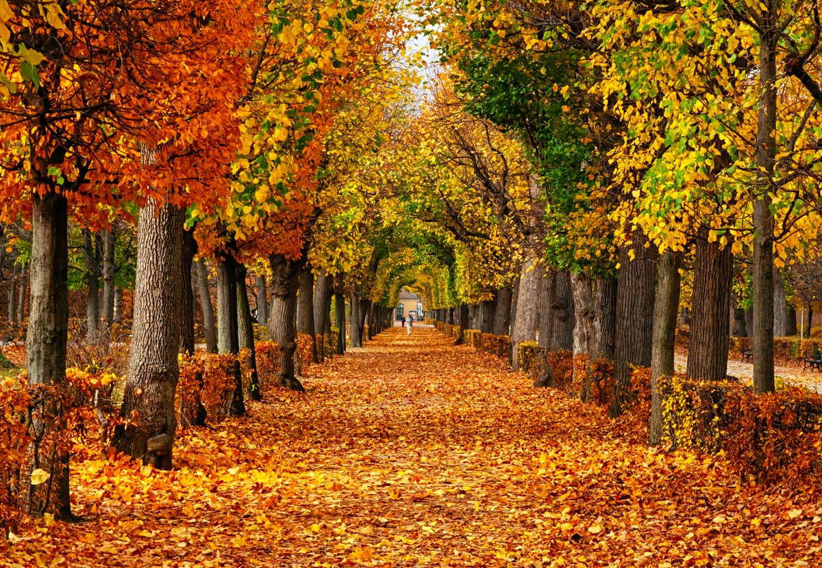
*Mission Project for September: Mending Hearts*
*Any questions please contact Rev. Brian Choi or Cindy Moore*

